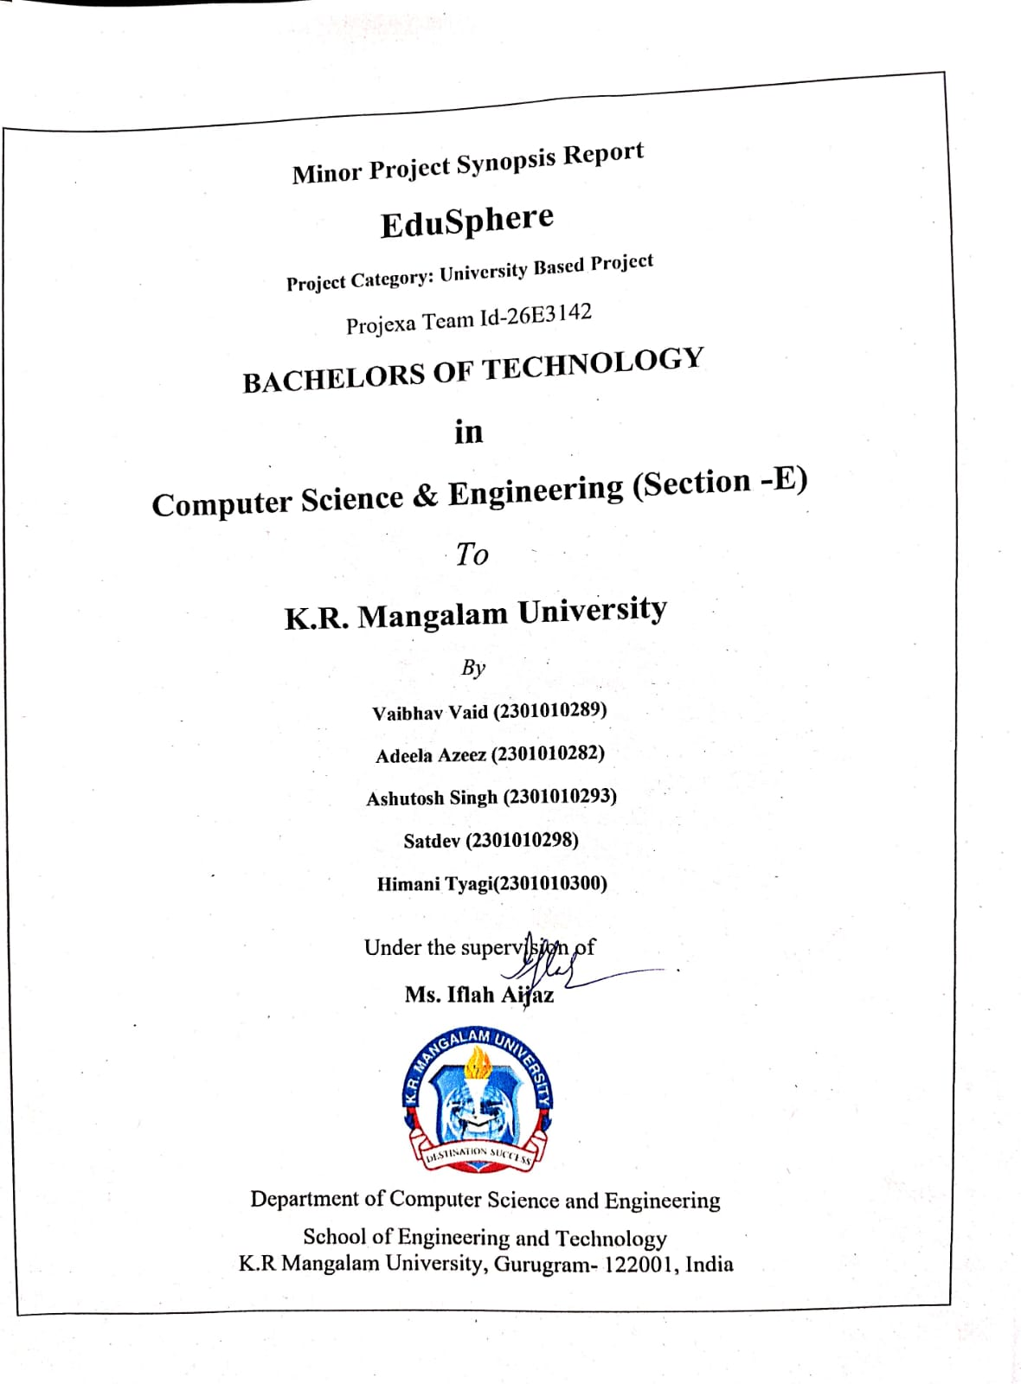

INDEX

S.No | Title | Page No.
1. | Abstract | 2
2. | Introduction | 3
3. | Motivation | 4
4. | Literature Review | 5
5. | Gap Analysis | 7
6. | Problem Statement | 8
7. | Objectives | 9
8. | Tools/platform Used | 10
9. | Methodology | 11
10. | References | 12

1. ABSTRACT

Universities manage a wide range of academic, administrative, and student support activities on a daily basis. However, these services are often handled through multiple independent systems or manual processes, leading to delays, lack of transparency, and increased workload for both students and staff. The absence of a centralized platform makes it difficult to track student requests, maintain records, and ensure efficient communication.

This project proposes the development of a Unified University Management & Student Support Platform, a web-based system that integrates academic management and student support services into a single digital solution. The platform provides role-based access for students, faculty, and administrators, allowing them to perform their respective tasks efficiently. By automating key processes and enabling real-time communication, the system aims to improve service delivery, reduce manual effort, and enhance the overall university experience.

2. INTRODUCTION
With the rapid growth of higher education institutions, managing academic operations and student services has become increasingly complex. Universities are required to handle large volumes of data related to students, faculty, examinations, attendance, scholarships, internships, and grievance redressal. Traditionally, these activities are managed using separate software tools, emails, notice boards, or physical office visits.

Such fragmented systems often result in poor coordination, delayed responses, and difficulty in maintaining accurate records. Students face challenges in accessing timely information, while faculty and administrators struggle with manual tracking and repetitive tasks. In the era of digital transformation, there is a strong need for an integrated and reliable system that can streamline university operations.

The Unified University Management & Student Support Platform focuses on addressing these issues by offering a centralized web application that simplifies academic management and improves communication between all stakeholders. The system aims to support efficient decision-making, enhance transparency, and provide a structured approach to managing university processes.

3. MOTIVATION
The rapid growth in the number of students and academic activities in universities has made traditional academic management systems increasingly inefficient. Many universities still rely on a combination of manual record-keeping, spreadsheets, emails, and disconnected web portals to manage academic operations. This often results in data redundancy, delayed communication, lack of transparency, and increased administrative workload.

Students frequently face difficulties in accessing accurate and up-to-date academic information such as schedules, notices, attendance records, and academic progress. Faculty members spend significant time managing student data manually, which reduces the time available for teaching and research. Administrators, on the other hand, struggle to maintain consistency and coordination across departments due to the absence of a unified system.

The motivation behind this project is to address these challenges by developing a centralized digital platform that simplifies academic processes and improves overall efficiency. The project is also motivated by the growing adoption of digital solutions in education and the need for scalable, secure, and user-friendly systems. By providing a single platform for academic services, the proposed system aims to enhance user experience, reduce operational overhead, and support the digital transformation of universities.

4. LITERATURE REVIEW
Several studies and existing systems highlight the importance of digital platforms in managing academic and administrative operations within universities. Learning Management Systems (LMS) such as Moodle and Google Classroom focus primarily on course delivery and learning resources, but they offer limited support for administrative and institutional data management. Similarly, enterprise resource planning (ERP) systems used by universities provide comprehensive administrative features but are often expensive, complex, and difficult to customize.

Research papers on university information systems emphasize the benefits of centralized data management, improved communication, and automation of academic workflows. Many studies report that integrated academic platforms lead to better decision-making, reduced human error, and enhanced transparency. However, literature also points out challenges such as poor usability, lack of real-time updates, and limited integration between academic and administrative modules.

Existing student portals often provide basic functionality such as viewing results or notices but fail to offer a holistic academic experience. Furthermore, some systems are designed without considering the diverse needs of students, faculty, and administrators, leading to low adoption rates. These findings indicate that while digital solutions exist, there is still a need for a flexible, integrated, and user-centric platform that effectively addresses the academic management requirements of modern universities.

LITERATURE REVIEW TABLE

S. No. | Author(s) & Year | Title | Methodology / Focus | Key Findings | Research Gap Identified
1 | Alalwan et al. (2017) | Factors influencing adoption of mobile learning in higher education | Empirical study on technology adoption | User-friendly interfaces and perceived usefulness significantly affect adoption | Limited focus on integrated academic management systems
2 | Altbach et al. (2019) | Trends in global higher education | Analytical study on higher education systems | Highlights the need for digital transformation in universities | Does not provide a unified digital platform solution
3 | Bates (2018) | Teaching in a digital age | Conceptual framework for digital learning environments | Emphasizes structured digital systems for academic support | Lacks implementation of administrative workflow automation
4 | DeLone & McLean (2003) | Information systems success model | Theoretical IS success model | System quality, information quality, and user satisfaction are key success factors | Model not applied to university-wide management platforms
5 | Ellis & Goodyear (2016) | Integrating digital and physical learning environments | Case studies in higher education | Digital platforms improve communication and transparency | Limited discussion on role-based access systems
6 | Kumar & Sharma (2020) | Digital platforms in higher education administration | Survey-based research | Digital systems reduce administrative workload and delays | No unified solution for students, faculty, and admins
7 | Ozkan & Koseler (2009) | Evaluation of e-learning systems | Multi-dimensional evaluation model | System usability and content quality affect system success | Focused only on learning systems, not administrative services
8 | Sarker et al. (2013) | Qualitative studies in information systems | Methodological review | User-centered design improves system effectiveness | Lacks application to academic support platforms

5. GAP ANALYSIS
A gap analysis is conducted to identify the shortcomings of the existing university management systems and to justify the need for the proposed solution.
Existing System Limitations
- Academic management and student support services are handled using multiple independent systems or manual processes.
- Lack of system integration leads to fragmented and inconsistent academic data.
- Students rely on notice boards, emails, and physical office visits for accessing academic information.
- No centralized platform exists for tracking attendance, results, grievances, and notifications.
- Grievance handling is manual and time-consuming, with no proper tracking mechanism.
- Faculty members face difficulty in monitoring student performance and managing academic records efficiently.
- Administrators experience challenges in workflow management and report generation.
- Absence of role-based access control increases security and data privacy risks.
- Manual data handling increases the chances of human errors and data redundancy.

6. PROBLEM STATEMENT
In most universities, academic management, student support services, and administrative processes are handled through multiple independent systems or informal communication channels. Students rely on notice boards, emails, messaging applications, and physical visits to administrative offices to access information related to attendance, examinations, results, scholarships, internships, mentoring, and grievance redressal. This fragmented approach leads to scattered information, inconsistent records, and delays in communication.
Due to the absence of a centralized platform, students often face difficulties in tracking their academic progress, receiving timely notifications, and following up on grievances or requests. Faculty members and administrators also experience challenges in managing attendance, monitoring student performance, responding to student queries, and maintaining accurate academic records. Manual or semi-automated processes increase the workload, introduce human errors, and reduce overall operational efficiency.
Furthermore, the lack of transparency in existing systems results in repeated queries, miscommunication, and dissatisfaction among students. Administrators struggle to generate consolidated reports, manage workflows efficiently, and ensure data security across different departments. The absence of role-based access and secure authentication mechanisms further raises concerns regarding data integrity and privacy.
Therefore, there is a critical need for a unified, secure, and digital platform that integrates academic management and student support services into a single system. Such a platform should provide role-based access for students, faculty, and administrators, ensure real-time information availability, improve transparency, streamline workflows, and enhance the overall efficiency of university operations.

7. OBJECTIVES
- To establish a centralised digital platform for coordinating academic, administrative, and student support services
- To get rid of disjointed systems such as manual office visits, emails, and notice boards
- To make information about attendance, tests, results, scholarships, internships, and mentoring easy access
- To increase transparency and communication among the administration, instructors, and students
- To facilitate the effective tracking and management of student complaints and requests
- To lessen the administrative burden, repetitive enquiries, and delays
- To keep secure and organised academic records
- To improve institutional effectiveness and the overall student experience
- To assist university officials in making data-driven decisions.

8. Tools/Technologies Used
To ensure a smooth and efficient development process, the following tools and technologies will be utilized in the development of EduSphere: Unified University Management & Student Support Platform:
- Front-end:
React.js will be used to develop interactive, responsive, and role-based user interfaces for students, faculty members, and administrators.
- Back-end:
Node.js with Express will be employed to handle server-side logic, authentication, role-based access control, and RESTful API development.
- Database:
MongoDB or PostgreSQL will be used to securely store user information, academic records, attendance data, grievances, and notifications.
- Security & Authentication:
JWT (JSON Web Tokens) will be implemented for secure authentication, along with Role-Based Access Control (RBAC) to restrict access based on user roles.
- UI/UX Design:
Figma will be used for wireframing and prototyping role-based dashboards and user workflows prior to implementation.
- Deployment & Environment Management:
The application will be deployed using local servers or Docker-based containerization for academic demonstration purposes. Cloud hosting is considered as part of future enhancements.
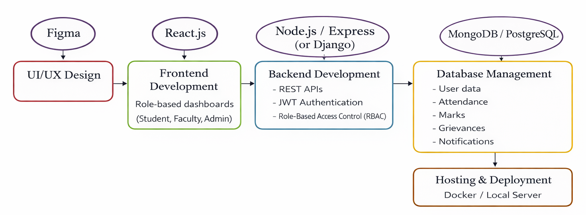

9. METHODOLOGY
The development of the EduSphere: Unified University Management & Student Support Platform will follow an iterative and user-centered development methodology. The project will be executed in structured phases to ensure usability, security, and scalability. The key phases include:
- Research and Analysis:
Study existing university management systems and identify challenges faced by students, faculty, and administrators in managing academic and administrative processes. Inputs will be gathered through discussions, observations, and analysis of current institutional workflows.
- Requirement Specification:
Define detailed functional and non-functional requirements for the Student, Faculty, and Admin modules based on the identified academic and administrative needs.
- Design and Prototyping:
Create system architecture diagrams, database schemas, and UI wireframes using tools such as Figma to visualize role-based dashboards and user interactions.
- Development:
Implement the platform using modern front-end and back-end technologies. Secure authentication, role-based access control (RBAC), and scalable RESTful APIs will be developed to ensure data integrity and system security.
- Testing and Validation:
Perform unit testing, integration testing, and usability testing to identify bugs, verify functionality, and validate system performance across all modules.
- Deployment and Maintenance:
Deploy the application using local or containerized environments (Docker). The system will be maintained and refined based on testing outcomes and future academic requirements.

REFERENCES

1. Laudon, K. C., & Laudon, J. P. (2020).
Management Information Systems: Managing the Digital Firm. Pearson Education.
🔗 Link
2. O’Brien, J. A., & Marakas, G. M. (2019).
Management Information Systems. McGraw-Hill Education.
🔗Link
3. Pressman, R. S., & Maxim, B. R. (2020).
Software Engineering: A Practitioner’s Approach. McGraw-Hill.
🔗Link
4. Sommerville, I. (2016).
Software Engineering. Pearson Education.
🔗 Link
5. UNESCO (2021).
Digital Transformation of Higher Education Institutions. UNESCO Publishing.
🔗 Link
6. UGC (University Grants Commission), India.
Guidelines on Digital Initiatives in Higher Education.
🔗 Link
7. Aljawarneh, S. A. (2017).
“Reviewing and Exploring Innovative University Management Systems.”
International Journal of Advanced Computer Science and Applications (IJACSA).
🔗 Link

